Difference Between Two-Tier And Three-Tier database architecture
• Read
• Discuss
• Courses

1. Two-Tier Database Architecture –
In two-tier, the application logic is either buried inside the User Interface on the client or within the database on the server (or both). With two-tier client/server architectures, the user system interface is usually located in the user’s desktop environment and the database management services are usually in a server that is a more powerful machine that services many clients.
2. Three-Tier Database Architecture –
In three-tier, the application logic or process lives in the middle-tier, it is separated from the data and the user interface. Three-tier systems are more scalable, robust and flexible. In addition, they can integrate data from multiple sources. In the three-tier architecture, a middle tier was added between the user system interface client environment and the database management server environment. There are a variety of ways of implementing this middle tier, such as transaction processing monitors, message servers, or application servers.
Difference Between Two-Tier And Three-Tier Database Architecture
S.NO | Two-Tier Database Architecture | Three-Tier Database Architecture
1 | It is a Client-Server Architecture. | It is a Web-based application.
2 | In two-tier, the application logic is either buried inside the user interface on the client or within the database on the server (or both). | In three-tier, the application logic or process resides in the middle-tier, it is separated from the data and the user interface.
3 | Two-tier architecture consists of two layers : Client Tier and Database (Data Tier). | Three-tier architecture consists of three layers : Client Layer, Business Layer and Data Layer.
4 | It is easy to build and maintain. | It is complex to build and maintain.
5 | Two-tier architecture runs slower. | Three-tier architecture runs faster.
6 | It is less secured as client can communicate with database directly. | It is secured as client is not allowed to communicate with database directly.
7 | It results in performance loss whenever the users increase rapidly. | It results in performance loss whenever the system is run on Internet but gives more performance than two-tier architecture.
8 | Example – Contact Management System created using MS-Access or Railway Reservation System, etc. | Example – Designing registration form which contains text box, label, button or a large website on the Internet, etc.
Parallel Databases :
Nowadays organizations need to handle a huge amount of data with a high transfer rate. For such requirements, the client-server or centralized system is not efficient. With the need to improve the efficiency of the system, the concept of the parallel database comes in picture. A parallel database system seeks to improve the performance of the system through parallelizing concept.
Need :
Multiple resources like CPUs and Disks are used in parallel. The operations are performed simultaneously, as opposed to serial processing. A parallel server can allow access to a single database by users on multiple machines. It also performs many parallelization operations like data loading, query processing, building indexes, and evaluating queries.
Advantages :
Here, we will discuss the advantages of parallel databases. Let’s have a look.
- Performance Improvement –
By connecting multiple resources like CPU and disks in parallel we can significantly increase the performance of the system.
- High availability –
In the parallel database, nodes have less contact with each other, so the failure of one node doesn’t cause for failure of the entire system. This amounts to significantly higher database availability.
- Proper resource utilization –
Due to parallel execution, the CPU will never be idle. Thus, proper utilization of resources is there.
- Increase Reliability –
When one site fails, the execution can continue with another available site which is having a copy of data. Making the system more reliable.
Performance Measurement of Databases :
Here, we will emphasize the performance measurement factor-like Speedup and Scale-up. Let’s understand it one by one with the help of examples.
Speedup –
The ability to execute the tasks in less time by increasing the number of resources is called Speedup.
Speedup=time original/time parallel
Where ,
time original = time required to execute the task using 1 processor
time parallel = time required to execute the task using 'n' processors
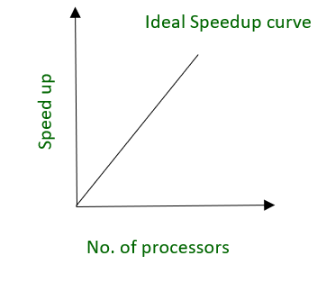
fig. Ideal Speedup curve
Example –
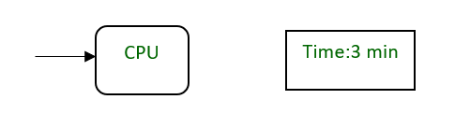
fig. A CPU requires 3 minutes to execute a process
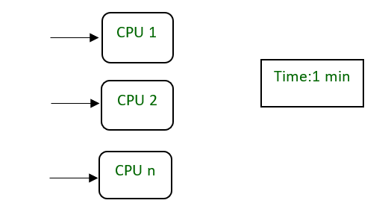
fig. ‘n’ CPU requires 1 min to execute a process by dividing into smaller tasks
Scale-up –
The ability to maintain the performance of the system when both workload and resources increase proportionally.
Scaleup = Volume Parallel/Volume Original
Where ,
Volume Parallel = volume executed in a given amount of time using 'n' processor
Volume Original = volume executed in a given amount of time using 1 processor
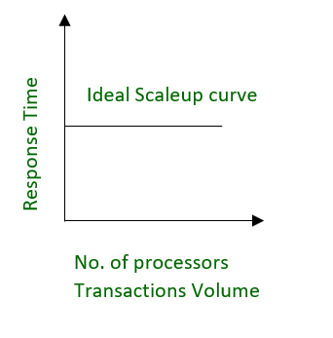
fig. Ideal Scaleup curve
Example –
20 users are using a CPU at 100% efficiency. If we try to add more users, then it’s not possible for a single processor to handle additional users. A new processor can be added to serve the users parallel. And will provide 200% efficiency.
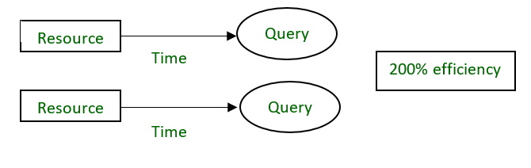
Unlock the Power of Placement Preparation!

